IIT2022004 (DAA Asgn: 1)

Q1)

The Following graph represents Linear Search time (in ms) vs n: It follows a complexity of o(n).

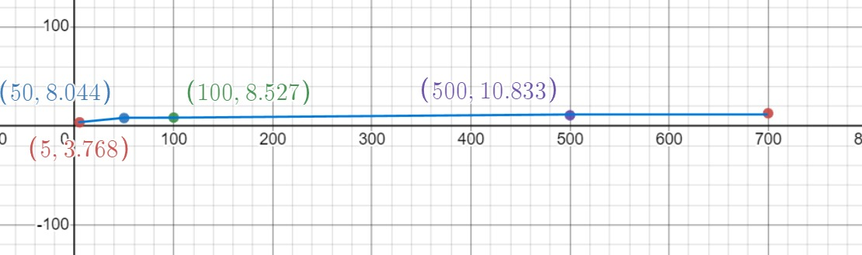

**Code:**

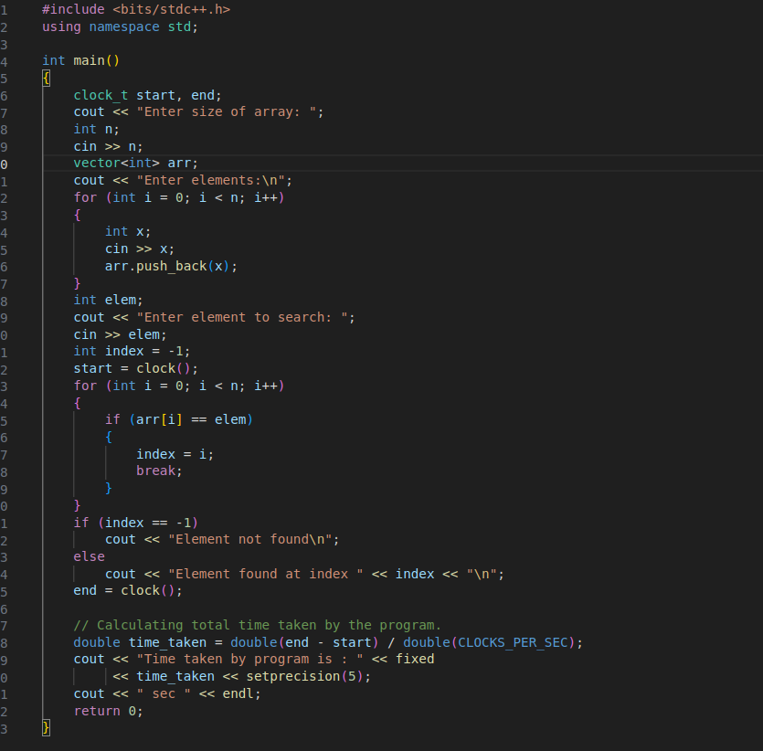

Q2)

he Following graph represents Binary Search time (in ms) vs n: It follows a complexity of O(log(n)).

